Eco News from the Telford Circuit

"They will plant vineyards and drink their wine; they will make gardens and eat their fruit." *Amos 9:14:*

Last week we talked about using our outside church spaces to attract and support wildlife. You might be interested to know that the Methodist Eco Community Network are next meeting (via zoom) on Wednesday 21st May at 7pm and the theme will be ‘Greening our Spaces: Window Boxes to Community Gardens’. You can book a free space at the meeting via this link: [Methodist Church Eco Community Network Tickets](https://www.eventbrite.co.uk/e/methodist-church-eco-community-network-tickets-1113977198789?aff=erelexpmlt)

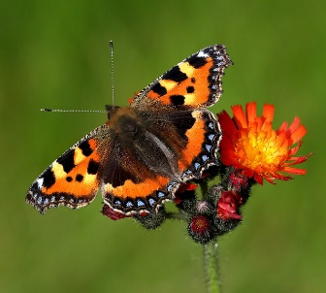Recent sunny weather has brought out butterflies but many of us have lamented the obvious decrease in the number and variety of butterflies we see around. According to *The State of the UK's Butterflies 2022 report*, released by Butterfly Conservation, 80% of butterflies in the UK have declined since the 1970s. One of the top tips for supporting butterflies is to let your grass grow. This alone is said to boost butterfly numbers by up to 93%. To find out more about No Mow May, click here: [Plantlife's No Mow May Movement](https://www.plantlife.org.uk/campaigns/nomowmay/)

Other ways to support insects and wildlife in your garden might be just the activity you are looking for to engage with children and young people; at home, at church or in your local community. Not only will you be sharing your love of nature with them but it will also give you the opportunity to share why it is so important to you that we look after God’s creation. See below for ideas of activities to do with children in a garden near you!

[How to Have an Insect Friendly Garden - Green Eco Friend](https://greenecofriend.co.uk/insect-friendly-garden/)  
[RSPB Wild Challenge for families](https://www.rspb.org.uk/helping-nature/what-you-can-do/activities/wild-challenge/wild-challenge-for-families)