The community of Ajumako Osedzi thank God and the Telford Methodist Circuit for the delivery of much needed equipment for their clinic (July 2025)

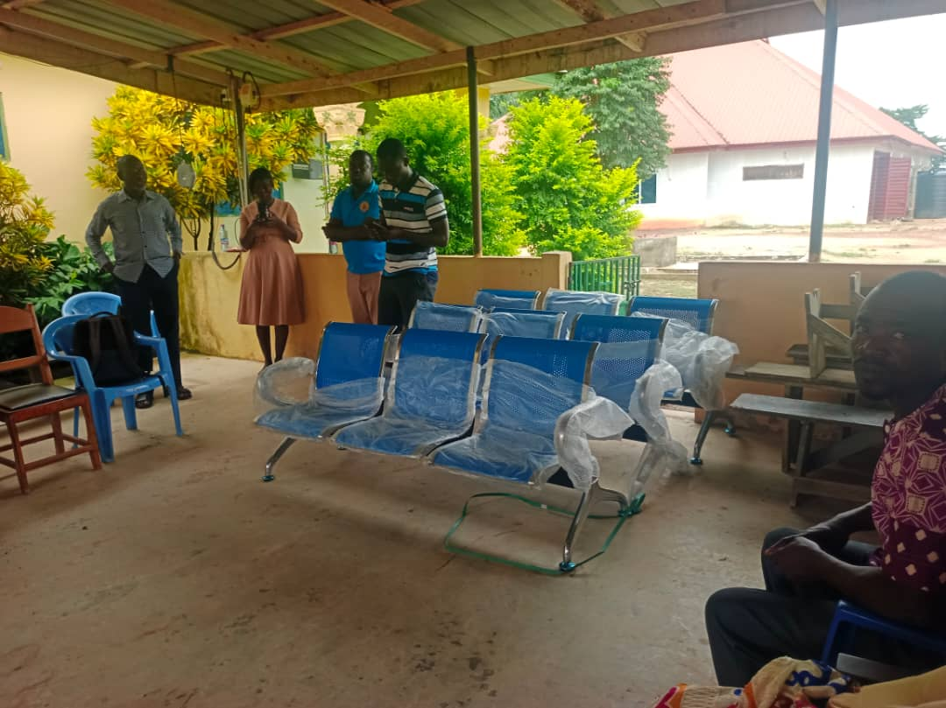

Watch the new sink being installed by clicking on the video link.

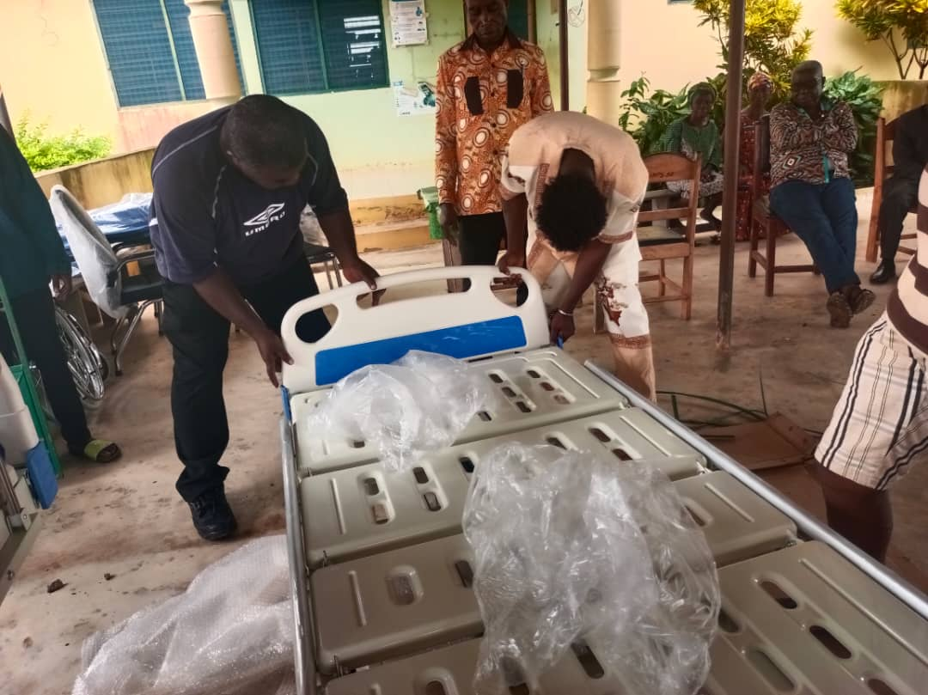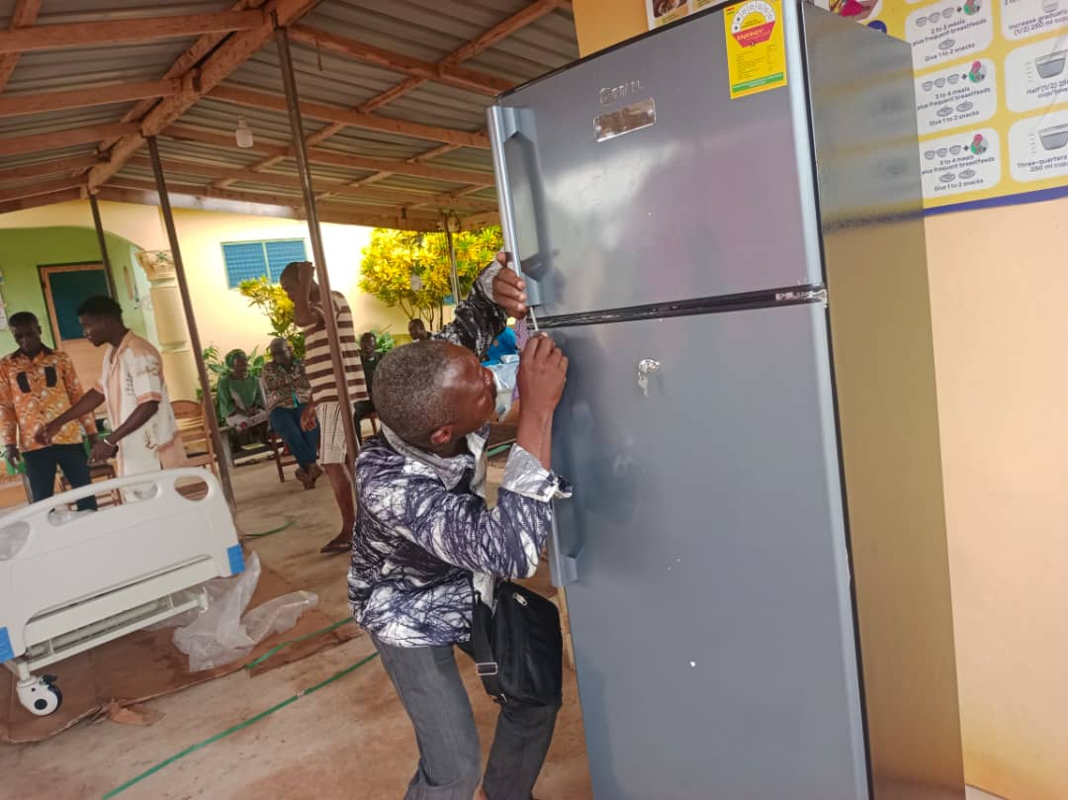

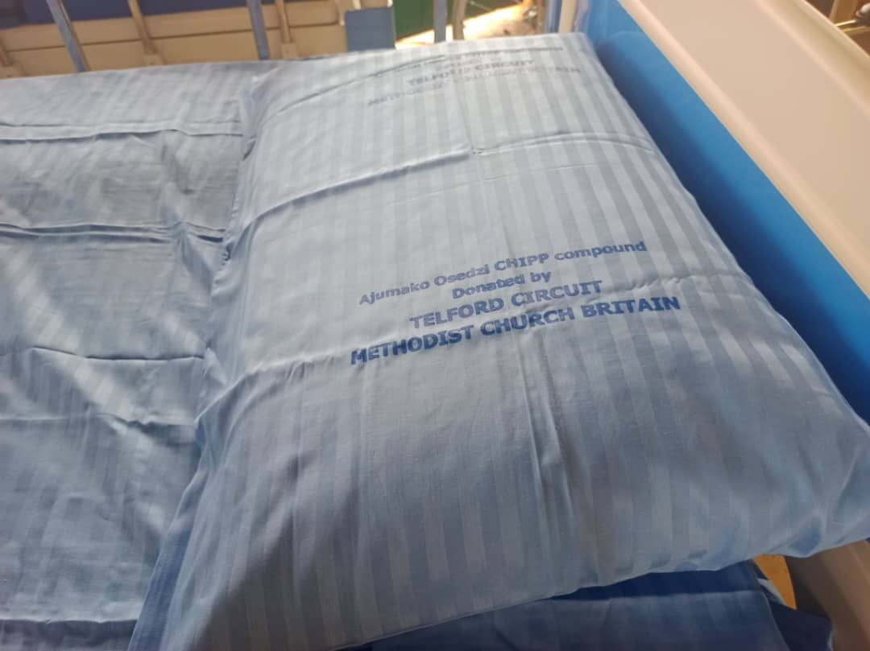



A special service to thank God and to bless the new equipment.

**We have managed to purchase everything on our list except a maternity bed (yet!). More photos to come when everything is installed.**