

Eco News from the Telford Circuit
For as the body without the spirit is dead, so faith without works is also dead. James 2:26

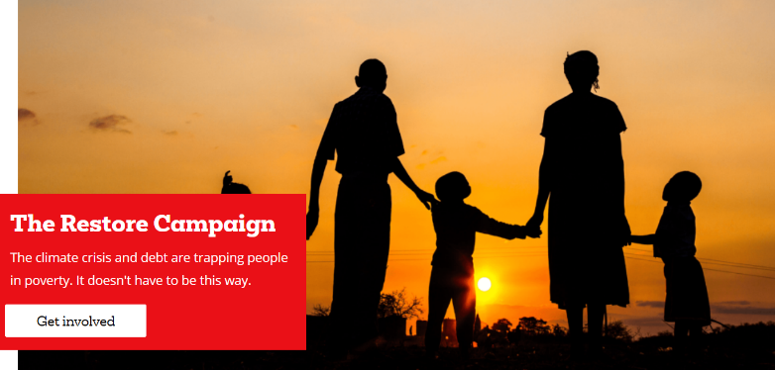
In the next few days Christians across the country will be raising money for Christian Aid. A key aspect of Christian Aid’s work is their campaign for climate justice and their work in equipping and enabling farmers with drought resistant crops and sustainable farming practices.
Could you and your church take part in their Restore Campaign? Find out more and sign their petition here
‘It’s the poorest, who have done the least to cause the climate crisis, who are paying the greatest price. Poverty and a deepening debt crises means poorer countries are struggling to respond. Meanwhile, the biggest polluters make vast profits from fossil fuels.’
‘Pray for justice’, the Christian Aid website

Could you commit to praying for Climate Justice? Christian Aid have produced prayers and prayer activities which you could use in your services or in your individual prayer time here
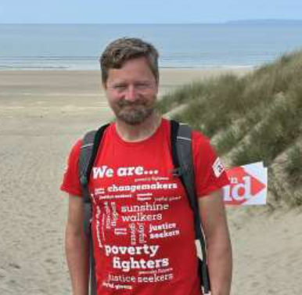
If you are unable to get involved in any other fundraising activities you could think about sponsoring our Faith Space friend Steve Allen, who is planning a sponsored walk to every church in the Black Country Circuit, a distance of over 18 miles. Stephen's fundraiser - Christian Aid Fundraise

