

Eco News from the Telford Circuit
How beautiful on the mountains are the feet of those who bring good news, who proclaim peace, who bring good tidings, who proclaim salvation, who say to Zion, “Your God reigns!” Isaiah 52:7

Firstly: Happy World Environment Day to you all!
Secondly: I bring good news!
Probably, like me, you are enjoying some summer weather and hopefully large heating bills and fuel costs are not foremost in your minds at the moment. Surely though, anything which might help us to plan ahead and reduce our heating bills this winter is a good thing.
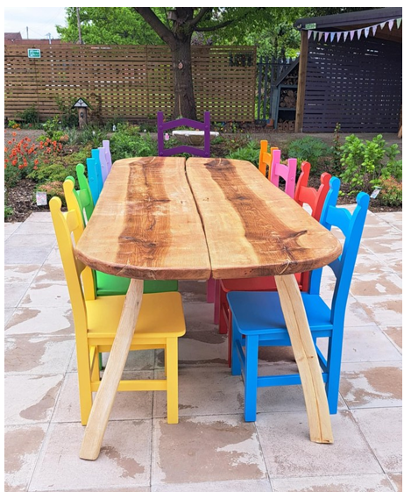
Browsing the Methodist Website ‘Latest Eco Stories’ (which is great for inspiration and ideas by the way) I noticed a reference to ‘HeatHack’, a free programme and guidebook with lots of easy-to-digest information and resources to help community building operators (such as churches) identify ways to save on heating. It includes a card game which can be used by a church group to consider the way that their building is used and heated now and into the future and to prioritise actions which will make a difference. At a time when we are looking to save money from our tight church budgets, this resource really does look worth investigating.
The next meeting of the Growth Team for Inclusion and Justice (which includes our environmental work) will be at Dawley on Wednesday 11th June at 7:30pm in the community garden (weather permitting). Could you come along to represent your church?
All are welcome.

