

Eco News from the Telford Circuit
And I brought you into a plentiful land to enjoy its fruits and its good things. But when you came in, you defiled my land and made my heritage an abomination. Jeremiah 2:7

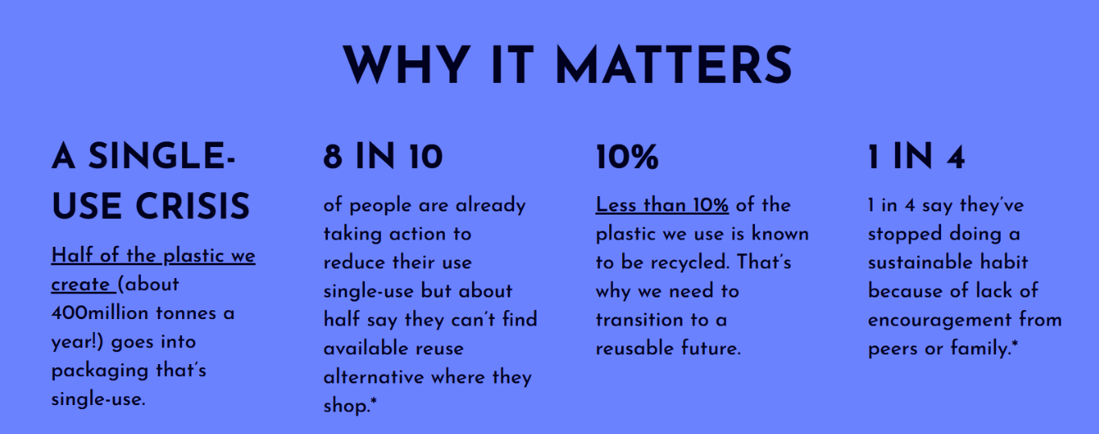
Coming soon… 16th June is World Refill Day.
More information at https://www.refill.org.uk/world-refill-day/
Right now, it is hard to avoid single use plastics. But the good news is that retailers do care about what we consumers want… we have more power than we realise.
What can we do? Can you commit to one action?
- Where possible, refill containers. There are green shops around our circuit where we can refill detergents and much more.
- Where possible, buy your fruit, vegetables and toilet paper loose or wrapped in paper.
- Avoid buying drinks in single use plastic bottles or cups – take your own reusable bottle or coffee cup and refill it!
- Could your church host a recycling centre for hard-to-recycle packaging?
Find out more here
- Tell your supermarket that plastic-free packaging is important to you!
Green and Zero Waste shops can be found at:
50 Mill Street, Bridgnorth; 12 High St, Much Wenlock; 2 Crown St, Wellington
There are also many farm shops and online retailers with plastic free products.

